Министерство образования Республики Беларусь

Учреждение образования

«Белорусский государственный университет   
информатики и радиоэлектроники»

Кафедра электронных вычислительных машин

Дисциплина: «Базы данных»

Лабораторная работа № 1

«Реализация SQL-запросов для создания схемы базы данных»

Выполнил: Полховский А. Ф.

Студент группы 990541

Проверил: Куприянова Д. В.

Минск 2022

Работа выполнялась с использованием СУБД PostgreSQL. Была создана база данных с названием «footballClub». Далее был написан скрипт для создания таблиц, установления ограничений и связей между таблицами:

CREATE TABLE sportsmen

(

ID SERIAL CONSTRAINT sportsmen_Id PRIMARY KEY,

fname CHARACTER VARYING(30) CONSTRAINT fname_nn NOT NULL,

sname CHARACTER VARYING(30) CONSTRAINT sname_nn NOT NULL,

amplua CHARACTER VARYING(30) CONSTRAINT amplua_nn NOT NULL,

birthday DATE CONSTRAINT birthday_nn NOT NULL,

nationality CHARACTER VARYING(30) CONSTRAINT nationality_nn NOT NULL

);

CREATE TABLE individual_achievments

(

ID SERIAL CONSTRAINT individual_achievments_id PRIMARY KEY,

sportsmen_id INTEGER,

aname CHARACTER VARYING(30) CONSTRAINT aname_nn NOT NULL,

FOREIGN KEY (sportsmen_id) REFERENCES sportsmen (Id)

);

CREATE TABLE trainer

(

ID SERIAL CONSTRAINT trainer_id PRIMARY KEY,

fname CHARACTER VARYING(30) CONSTRAINT fname_nn NOT NULL,

sname CHARACTER VARYING(30) CONSTRAINT sname_nn NOT NULL,

birthday DATE CONSTRAINT birthday_nn NOT NULL,

nationality CHARACTER VARYING(30) CONSTRAINT nationality_nn NOT NULL,

main_ahchievment CHARACTER VARYING(30) CONSTRAINT main_ahchievment_nn NOT NULL

);

CREATE TABLE team

(

ID SERIAL CONSTRAINT team_id PRIMARY KEY,

sportsmen_id INTEGER,

trainer_id INTEGER,

tname CHARACTER VARYING(30) CONSTRAINT tname_nn NOT NULL,

FOREIGN KEY (sportsmen_id) REFERENCES sportsmen (Id),

FOREIGN KEY (trainer_id) REFERENCES trainer (Id)

);

CREATE TABLE club

(

ID SERIAL CONSTRAINT club_id PRIMARY KEY,

team_id INTEGER,

cname CHARACTER VARYING(30) CONSTRAINT cname_nn NOT NULL,

country CHARACTER VARYING(30) CONSTRAINT country_nn NOT NULL,

FOREIGN KEY (team_id) REFERENCES team (Id)

);

CREATE TABLE match_result

(

ID SERIAL CONSTRAINT match_result_id PRIMARY KEY,

team_id INTEGER,

competitor CHARACTER VARYING(30) CONSTRAINT competitor_nn NOT NULL,

mresult CHARACTER VARYING CONSTRAINT mresult_nn NOT NULL,

seson CHARACTER VARYING(30) CONSTRAINT seson_nn NOT NULL,

league CHARACTER VARYING(30) CONSTRAINT league_nn NOT NULL,

FOREIGN KEY (team_Id) REFERENCES team (Id)

);

CREATE TABLE club_owner

(

ID SERIAL CONSTRAINT club_owner_id PRIMARY KEY,

club_id INTEGER,

fname CHARACTER VARYING(30) CONSTRAINT fname_nn NOT NULL,

sname CHARACTER VARYING(30) CONSTRAINT sname_nn NOT NULL,

birthday DATE CONSTRAINT birthday_nn NOT NULL,

nationality CHARACTER VARYING(30) CONSTRAINT nationality_nn NOT NULL,

FOREIGN KEY (club_Id) REFERENCES club (Id)

);

CREATE TABLE stadium

(

ID SERIAL CONSTRAINT stadium_id PRIMARY KEY,

team_id INTEGER,

sname CHARACTER VARYING(30) CONSTRAINT sname_nn NOT NULL,

capacity INTEGER,

foundation_date DATE CONSTRAINT foundation_date_nn NOT NULL,

FOREIGN KEY (team_Id) REFERENCES team (Id)

)

После применения скрипта средствами СУБД была построена база данных, которая представлена ниже.

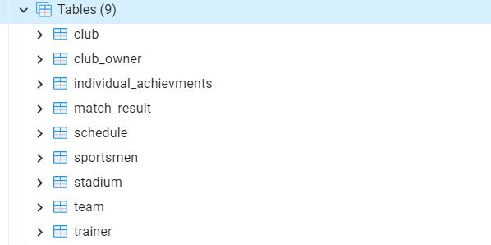

Затем заполним БД данными.

INSERT INTO individual_achievments (sportsmen_id, aname)

VALUES

(1, '4 Times get Golden Ball'),

(2, '4 Times get Golden Ball'),

(3, 'Top 10 Young Player in World'),

(4, 'Russian Capitan 2010-2o16'),

(5, 'Main GK of Russia Top 2 2020'),

(6, 'DF, nomimated on Golden Ball')

INSERT INTO trainer (fname, sname, birthday, nationality, main_ahchievment)

VALUES

('Andrei', 'Ostapenko', '16.04.1982', 'England', 'League Champions(1999)'),

('Andres', 'Iniesta', '20.02.1977', 'Spain', 'Chinese tournament(1980)'),

('Stanislav', 'Cherchesov', '02.09.1963', 'Russia', 'Top2 Sbornaya Rossii(2020)'),

('Valeriy', 'Karpin', '12.02.1975', 'Russia', 'Sbornaya Rossii'),

('Endrew', 'Donaruma', '11.02.1978', 'Portugal', 'Sbornaya Rossii'),

('Konstantin', 'Pleshev', '09.01.1981', 'Belarus', 'Olimpics winner 2002')

INSERT INTO club (team_id, cname, country)

VALUES

(1, 'Premier League', 'England'),

(2, 'La league', 'Spain'),

(3, 'French Football league', 'France'),

(4, 'RussPremier League', 'Russia'),

(5, 'RussPremier League', 'Russia'),

(6, 'Belarus League', 'Belarus')

INSERT INTO team (sportsmen_id, trainer_id, tname)

VALUES

(1, 1, 'Manchester city'),

(2, 5, 'Barcelona'),

(3, 2, 'Paris Saint Germain'),

(4, 4, 'Spartak'),

(5, 3, 'Dinamo'),

(6, 6, 'Bate')

INSERT INTO club_owner (club_id, fname, sname, birthday, nationality)

VALUES

(6, 'Mansur ibn Zaid', 'Al Nahaiyan', '29.04.1967', 'UAE'),

(7, 'Joan', 'La Porte', '20.09.1955', 'Spain'),

(8, 'Nasser', 'Ganim Al-Xhelafi', '12.11.1973', 'Katar'),

(9, 'Leonid Arnoldovich', 'Fedun', '05.04.1956', 'Russia'),

(10, 'Leontiy Leonidovich', 'Karanin', '12.12.1977', 'Russia'),

(11, 'Anatoliy Fedorovich', 'Kapskiy', '19.02.1966', 'Belarus')

INSERT INTO stadium (team_id, sname, capacity, foundation_date)

VALUES

(1, 'Old Trafford', 76000, '10.09.1910'),

(2, 'Camp Nou', 99354, '24.09.1957'),

(3, 'Parc des Princes', 49691, '01.09.1897'),

(4, 'Otkritie Bank Arena', 45360, '05.09.2014'),

(5, 'VTB Arena', 33000, '19.09.1928'),

(6, 'Borisov Arena', 13121, '03.05.2014')

INSERT INTO match_result (team_id, competitor, mresult, seson, league)

VALUES

(1, 'Manchester United', 'WIN', '22', 'Champions League'),

(2, 'Real Madrid', 'WIN', '22', 'La League'),

(3, 'Uventus', 'LOSE', '22', 'Champions League'),

(4, 'Tor Gdansk', 'WIN', '21', 'European Championship'),

(5, 'Dynamo Kiev', 'LOSE', '22', 'European Championship'),

(6, 'Dynamo Minsk', 'WIN', '22', 'Belarusian Championship')

INSERT INTO schedule (team_id, trainer_id, sday)

VALUES

(1, 1, '05.07.2022'),

(2, 2, '25.06.2022'),

(3, 3, '30.06.2022'),

(4, 4, '30.06.2022'),

(5, 5, '10.08.2022'),

(6, 6, '21.07.2022')

Таблица sportsmen.

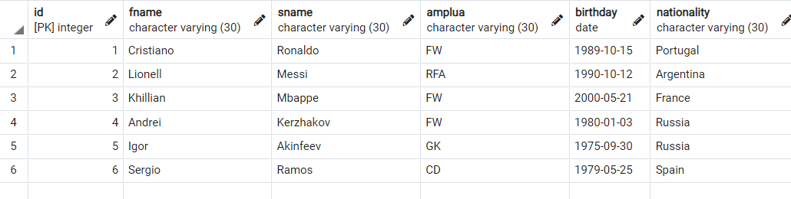

Таблица individual-achievments.

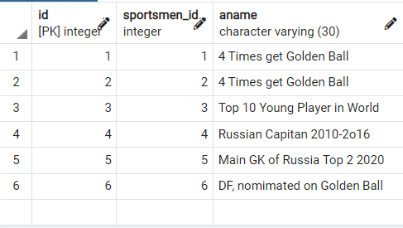

Таблица trainer.

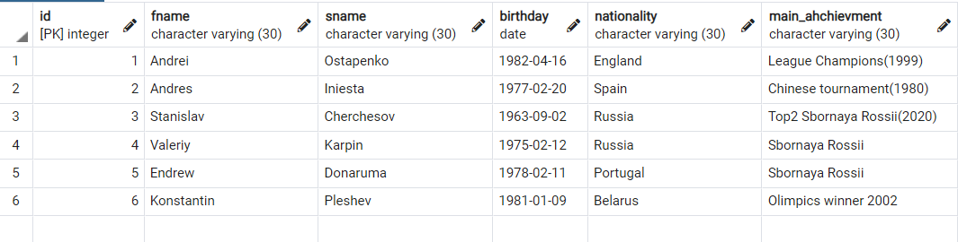

Таблица team.

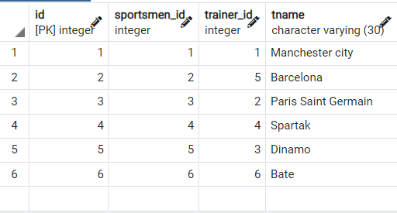

Таблица club.

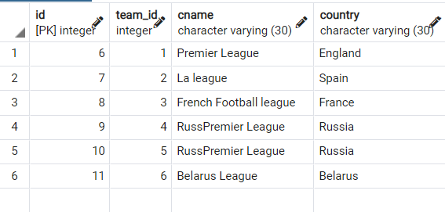

Таблица club-owner.

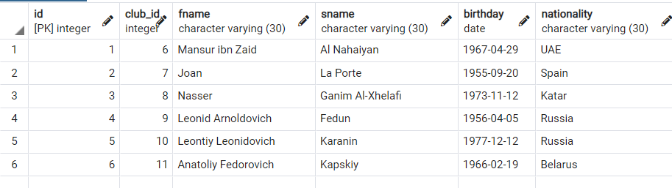

Таблица stadium.

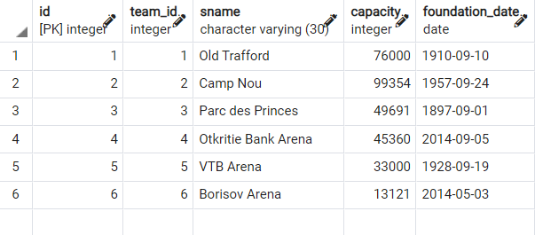

Таблица match-results.

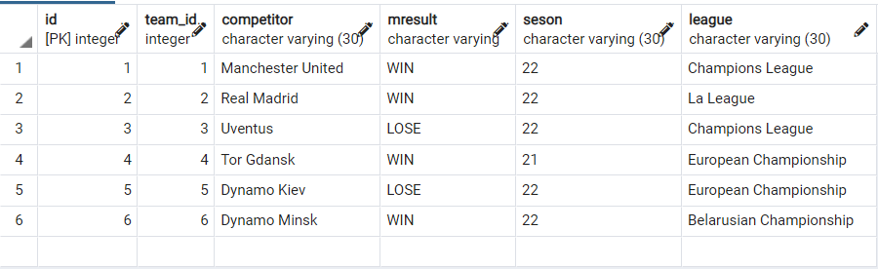

Таблица schedule.

